|  |  |
| --- | --- |
| Nikon Z7 II  Máy ảnh Nikon Z7 II (Body Only)  nikon-z7-ii nikon-z7-ii-8 nikon-z7-ii-4 nikon-z7-ii-7 | **Featured information:**  EXPEED 6 image processor  BSI CMOS FX 45.7MP sensor  Continuous shooting at 10 fps, ISO 64-25600  UHD 4K60 Video Recording  Price: $ 2350  **Specifications:**   * Viewfinder Resolution * 3,690,000 Dots * Viewfinder Coverage * 100% * Viewfinder Magnification * Approx. 0.8x * Screen Size * 3.2" * Screen Resolution * 2,100,000 Dots * Screen Characteristics * Tilting Touchscreen LCD * Viewfinder Type * Electronic * Viewfinder Size * 0.5" |

**Overview:**

Succeeding Nikon's first two Z-mount camera models named Z6 and Z7, with many highly appreciated features, the company continues to launch Nikon Z7 II with new improvements, providing the ability to record videos and take photos. More powerful images, meeting more demanding needs of users.

Still retaining the same strong design as the previous two generation Z-mount cameras, the Z7 II is mostly made from durable magnesium alloy, allowing it to withstand harsh weather. Helps photographers shoot in all different conditions while still ensuring the best image and video quality.

With a deep grip, the Nikon Z7 Mark II feels sturdy and comfortable in handheld photography. At the same time, possessing a compact and flexible size helps users to carry the camera with them for work anywhere very conveniently without worrying about being bulky or difficult when moving.

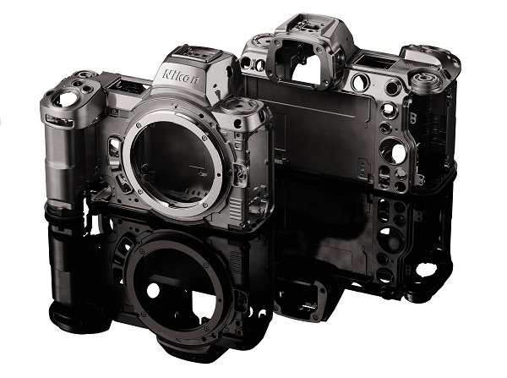

Not only possessing powerful photography capabilities, the Nikon Z7 II can also record high-quality 4K Video at 60 frames per second to deliver sharp, smooth footage. The captured video can be saved to a memory card or external buffer via the HDMI port.

In addition, the Z7 II also integrates many advanced recording modes such as N-Log and HDR that allow you to output high-quality 10-bit video via the HDMI port, making post-production editing easier and faster.

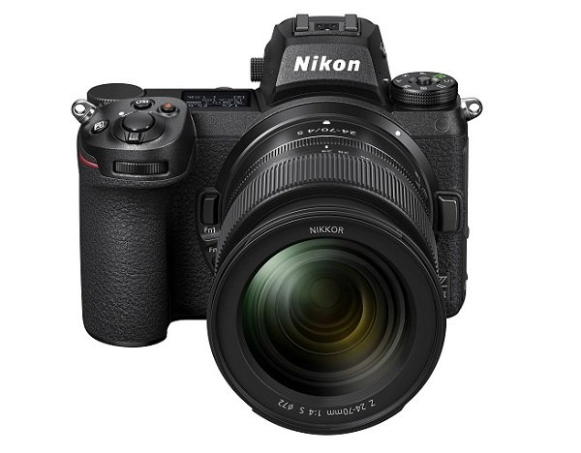

Similar to the Z6 and Z7, the Nikon Z7 II camera also has an integrated EVF electronic viewfinder with a resolution of 5.67 million dots, helping images displayed through the viewfinder appear clear and realistic even when taking photos under strong sunlight. , thereby giving the shooting results closest to the image displayed when viewing.

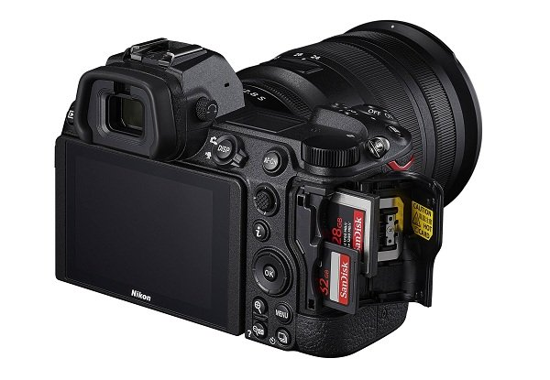

The camera integrates a 3.2-inch LCD touch screen with a resolution of 2.1 million pixels and tilt capability to help photographers take photos in many difficult situations. The touch screen makes setting modes faster with just one touch.